Exercises 10 – Random Numbers

- Write a program that will display a circle in the middle of the screen in a random colour. 10_1.t
Hint:
- use drawfilloval (x, y, xRadius, yRadius, Color : int)
The drawfilloval procedure is used to draw a filled oval whose center is at (x, y). The horizontal and vertical distances from the center to the oval are given by xRadius and yRadius. To get an oval outlined in a different color, use drawfilloval with the Color parameter set to the fill color and then call drawoval with the Color parameter set to the border color.
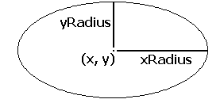
- use maxx and maxy for the center

- Write a program that will randomly select two numbers between 1 and 100 and display the numbers in the form of an addition question. The user should have the opportunity to enter an answer until they get it right. 10_2.t

- Guess Again. Write a program which generates a random number in the range of 1 to 50. The user has to guess what the number is. The program should respond HIGH, LOW, or CORRECT. Output the appropriate message. 10_3.t

